CHEMICAL ENGINEERING TRANSACTIONS  VOL. 93, 2022 | A publication of
The Italian Association
of Chemical Engineering
Online at www.cetjournal.it

Guest Editors: Marco Bravi, Alberto Brucato, Antonio Marzocchella
Copyright © 2022, AIDIC Servizi S.r.l.
ISBN 978-88-95608-91-4; ISSN 2283-9216

Granulation and Activation of an Arsenic Adsorbent Made of Iron Oxide Doped Hydrochar
Paulo A.M. Mourão^{a,*}, Fabrizio Di Caprio^{b,*}, Isabel P.P. Cansadoª, José E. Castanheiroª, Ilario Falcone^{c}, Maria Luisa Astolfi^{b}, Pietro Altimari^{b}, Francesca Pagnanelli^{b}
ªMED, Instituto de Investigação e Formação Avançada, Departamento de Química, Escola de Ciências e Tecnologia, Universidade de Évora, Rua Romão Ramalho 59, 7000-671 Évora, Portugal
^{b}Dipartimento di Chimica, Sapienza Università di Roma, Piazzale Aldo Moro 5, 00185, Rome, Italy
^{c}Technosind S.r.l., Via di Vannina, 88, 00156, Rome, Italy
pamm@uevora.pt; fabrizio.dicaprio@uniroma1.it
Water contamination by arsenic (As) takes place over extended geographic areas and it represents an environmental issue of global concern due to the severe threats to human health. One main limitation in applying As treatment systems is the high cost of conventional adsorbents (5-10 € kg⁻¹, granular ferric oxides, GFO). In recent studies, hydrothermal carbonization (HTC) was proved to be a promising process to convert olive pomace (an agro-industrial by-product) to an innovative adsorbent for As removal by combining HTC with iron oxide doping (by precipitation). However, to date, a major gap in this scientific field is the needing for scalable granulation and activation systems to convert the hydrochar powder to particles with higher size, surface area and water stability (namely reduced release of organics), suitable for their use in fixed bed-columns. The aim of this work was to contribute on filling this gap, by studying a process to transform the bio-adsorbent powder (iron doped hydrochar, IH) to granules usable in fixed bed columns. Different common binders were compared; among these, sodium silicate showed better results, at content between 36-53 %, allowing to produce an adsorbent able to remove up to 12.2 mg g⁻¹ As. However, the increase in activation temperature and silicate % increased the alkaline property of the adsorbent, which required up to 9.4 mol H⁺ g⁻¹ for neutralization, indicating a preliminary washing required before its application for water treatment. Preliminary cost analysis indicated that the cost to be sustained for silicate binder addition could be compatible with the production of a cheaper adsorbent; however, a more comprehensive analysis of the whole process is required.
  - Introduction
Arsenic (As) is released in the environment from natural and anthropogenic sources (e.g. geochemical, volcanic, mining and others) in most diverse locations (e.g. Europe, Asia), where it often constitutes a worldwide health problem (Podgorski et al., 2020), mainly when this metal is present in high concentrations in water used for human consumption (Rahaman et al., 2022). Aware of the harmful impacts of this reality, in 1993 the World Health Organization (WHO) reduced the maximum value for As in water for human consumption from 50 to 10 µg L⁻¹, which the European Union adopted in 2003 (Directive 98/83/EC). This legal framework requires an effort by government entities and companies in the water treatment sector to reduce the costs of the processes used and, in particular, the high costs (5-10 € kg⁻¹) of the adsorbents conventionally used (GFO) (Nicomel et al., 2015). As precursor materials and by-products of various activities, lignocellulosic materials are cheap sources of renewable materials with high potential for use in large-scale industrial processes (Gil, 2021). Among these, olive pomace is a by-product of olive oil industrial production, produced in high quantity in countries like Italy, Portugal, and Spain (13 ∙ 10⁶ t were produced on 2017/2018 campaign). Therefore, its valorisation is an opportunity and a challenge for a circular economy (Miranda et al., 2019). This biomass waste can be transformed to an adsorbent by hydrothermal carbonisation (HTC) accompanied by the process of doping by iron oxide precipitation, increasing the As adsorption capacity and water stability of the adsorbent (Capobianco et al., 2020). However, this adsorbent has been only produced as a powder with granulometry mostly between 90-500 µm (Capobiando et al. 2020), which is difficult to use in fixed-bed columns. The feasibility of using this iron oxide doped hydrochar (IH) powder depends on the ability to aggregate it into a granulate, maintaining the sufficiently high surface area and water and mechanical stability. In addition, the adsorbent should match a suitable particle size (0.3 - 5 mm of size) to be used in conventional plants (fixed bed-columns) for replacing conventional adsorbents, avoiding overpressure. Among the various possible granulation techniques, such as moulding, extrusion, wet or dry, granulation by "spray rotary" can be classified as environmentally friendly as it involves fewer steps and less material and energy. However, since it does not use any kind of external pressure, the main challenge is finding a strong and fast acting binder. The literature shows many potential binders for the agglomeration of adsorbents. The viability of the process implies a considerable binder: adsorbent ratio (usually higher than 1:3, frequently higher than 1:2, and even 1:1). Long processes, high pressure and agglomerates (namely crosslinking agents) are frequently required to obtain the agglomerated grains. These binders can be of natural origin (e.g., starch, clay) or synthetic origin (e.g., synthetic polymers, tar).
The aim of this study was to obtain a process to agglomerate and stabilize oxide doped hydrochar, which could be environmentally and economically sustainable for application at an industrial scale for producing an innovative adsorbent material for As, to replace conventional GFO.
  - Experimental
Materials
All chemicals are commercially available and were used as received. Sodium alginate, SA (Technical grade, VWR), Carboxymethyl cellulose, CMC (Technical grade, Fragon), Chitosan, CH (Medium molecular weight, Sigma-Aldrich), Starch soluble, ST (Iso, Merck), Cement, CE (SECIL), Clay, CL (Technical grade, Labchem), Poly(acrylic acid), PAC (Mw ~1800, Sigma-Aldrich), Poly(vinyl alcohol), PVA (Mw 146,000-186,000, 99 % hydrolyzed, Sigma-Aldrich), Sodium silicate, SS (Technical grade, neutral solution, PanReac), Vegetal Charcoal Activated, VCA (Analytical reagent, VWR). Olive pomace (OP) was collected from a continuous three-phase olive oil mill plant at Rocca Massima (Italy). It was dried at 60 °C until constant weight, manually ground and sieved to remove particles >1 mm (olive stones and leaves). H₂SO₄ (96 %), FeCl₃∙6H₂O (99 %), FeSO₄∙7H₂O (99 %), KOH (99 %) and KH₂AsO₄ (98–102 %, A6631) were all purchased from Sigma Aldrich.
Iron oxide doped Hydrochar (IH) synthesis
IH was prepared as follows: 5.0 g of olive pomace were added inside 100 mL polytetrafluoroethylene (PTFE) vessel, with 20 mL feedwater solution (FeCl₃∙6H₂O 22.0 g L⁻¹, FeSO₄∙7H₂O 15.4 g L⁻¹, pH 0.5 adjusted with H₂SO₄). HTC was performed for 30 min at 200 °C by microwave heating (Milestone Laboratory System Labstation). After cooling, the suspension was moved inside a 100 mL glass reactor under N₂ flow, at 80 °C under magnetic stirring. After 30 min, 4 mL KOH (6.4 M) were added dropwise. The suspension was then vacuum filtered throughout paper filters and dried at 105 °C till constant weight. Yield for IH production and Fe doping were determined by measuring the final amount of IH and its Fe content, as described in a previous work (Di Caprio et al. 2022).
Granulation and activation: comparison between different binders
Granulation was performed manually with the use of a plastic container in which the VCA powder (~ 1 g) was dispersed and over which 15, 10, 33, 15, 10, 33, 33, 50, 16 % (Binder mass ∙ VCA mass⁻¹) of the binders SA, CMC, CH, ST, CE, CL, PAC, PVA and SS were added, respectively, together with enough water sprayed to obtain granulation of the mixture. Then, the granules were submitted to a pre-drying step in an oven at 120 ºC for at least 24 h. The granules were then activated at T_{max} 250 °C and 500 °C (10 ºC min⁻¹ up to T_{max}) under N₂ atmosphere. Whenever at the end of each stage the materials did not resist its handling (disintegrating), they didn't pass to the next stage.
Granulation and activation: optimization of SS% and activation conditions
Sodium silicate (SS) was tested at different %. Granulation was carried out manually with the use of a plastic container in which the IH powder (0.9 g) was dispersed and over which different masses (3.5 g, 5 g and 5 g) of various SS solutions (5 %, 10 % and 20 %) were sprayed subjecting the whole set to a manual continuous centrifugal movement. The resulting final SS% were 16 %, 36 % and 53 % w/w (as SS ∙ (IH+SS)⁻¹). The pulverization and centrifugal movement steps were repeated, as many times as necessary, until granules were obtained. These samples were activated at T_{max} 300 °C and 500 ºC under the atmosphere of sole N₂ flow or under N₂ flow followed by pure CO₂ flow when the T_{max} was reached (N₂→CO₂, both of 150 mL min⁻¹), in a horizontal tubular furnace TR-334/2018 (Termolab). T_{max} was maintained for 7 h. The designation of the samples at different SS% follows the format IH-SS%-T/Gas, as an example IH-16-300/N₂: 16 % of SS, T_{max} 300 ºC, under N₂ atmosphere only.
Adsorbent characterization
The textural characterization was made by N₂ adsorption at -196 ºC, after degasification of samples at 200 ºC (2 h) on an equipment ASAP 2010 V1.01 B (Micromeritics), while the apparent specific surface area was determined using the BET method. Arsenic adsorption capacity (q_{As}) was measured as follows: 20 mg of adsorbent were suspended in 20 mL of 15 mg L⁻¹ As (as KH₂AsO₄) inside 50 mL glass bottles, under constant magnetic stirring and 25 ± 3 °C. The pH was periodically controlled with a pHmeter at 5.0 ± 0.2 by adding aliquots of 0.1 M HCl. A sample was collected (by centrifugation at 4,500 rpm) after 24 h for analysis. As, Na, K, C, Si and Fe concentration were determined by inductively coupled plasma optical emission spectrometry (ICP-OES; Vista MPX CCD Simultaneous, Varian) as described previously (Di Caprio et al. 2022). The q_{As} was determined by Eq (1):
$q_{As}= \frac{V \left(C_{0}-C_{f}\right)}{m_{f}}$ (1)
With V the suspension volume, C₀ and C_{f} initial and final As concentration and m_{f} the final mass of the adsorbent. At the end of the adsorption test, m_{f} was measured by filtering the whole suspension through 0.7 μm glass fiber filters and drying at 105 °C. Adsorbent water stability was measured as mg/g mass lost by Eq(2). The contribution to Δ_{m} by the different elements measured in solution was quantified by Eq(3).
$∆_{m}=\frac{m_{0}-m_{f}}{m_{0}}$ (2)
$∆_{i}=\frac{{V (C}_{i,f}-C_{i,0})}{m_{0}}$ (3)
With C_{i,f} and C_{i,0} the concentration of the i-element (Na, K, C, Si, Fe) at the end and beginning of the adsorption test. The acid-base reactivity of the adsorbent was determined by measuring the HCl (mg g⁻¹) and equivalent mol of H⁺ (mol g⁻¹) added per gram of adsorbent to attain a stable pH 5.0.
  - Results and Discussion
Preparation of Iron oxide doped Hydrochar (IH)
The IH was produced with a whole yield (yield HTC ∙ yield precipitation) of 55 ± 6 %. In the conditions adopted for synthesis, Fe mainly precipitated as Fe₃O₄ (Di Caprio et al. 2022). The IH contained 40 ± 7 mg g⁻¹ of Fe, corresponding to 5.5 % by weight of Fe₃O₄. The Fe precipitation yield in the IH was 70 ± 10 %. The reduction in Fe yield was mainly ascribable to Fe complexation with organic compounds released at the relatively high hydrochar concentration used (100 ± 20 g L⁻¹).
Granulation
To evaluate the adhesion capacity and aggregation potential of several binders, of natural and synthetic origin, in a first moment, as a result of the small amount available of IH, a preliminary screening test was performed with a commercial activated carbon material of lignocellulosic origin (VCA), of similar nature of the IH. Although the literature shows a reasonable number of binders that can be used for this type of powder, the available published procedures indicate the need for reasonably high amounts of binder, almost always higher than 30 % of the mass of the aggregate material and frequently above 50 %. On the other hand, the mechanical stability of the granulated material when submitted to thermal processes, necessary for certain purposes, is often compromised when the thermal treatment is superior to 250 ºC. In this work, the selected binders and the results in the granulation, pre-drying and thermal activation phases are shown in Table 1.
The results show that most of the selected binders, when dispersed in spray, can aggregate the adsorbent powder, which can be interpreted as a good capacity of adhesion and bonding of the binder under the conditions used (binder solutions with concentration up to 30 % w/V). However, in the pre-drying phase, some of these aggregates lose consistency, in result of the reduction of mechanical stability, ending up by losing their shape. This may be due to the weakening of the physical and chemical interactions between binder and adsorbent, release of water and other gaseous compounds, lack of cross-linking agents, among others. When the thermal activation process in controlled atmosphere was carried out at the studied temperature range (from 250 to 500 ºC), only the adsorbents prepared with sodium silicate continued to present the mechanical and dimensional resistance acceptable for use in the water phase. In the case of sodium alginate and polyvinyl alcohol binders, those characteristics disappear when the maximum temperature exceeded 250 ºC.
Table 1: Evaluation of the mechanical stability during the various stages of processing of the granulated adsorbent by binder spray. pass; x don’t pass; +/- variable.
Binder | Granulation | Drying | Activation
Sodium alginate - SA |  |  | +/-
Carboxymethyl cellulose - CMC |  | x | -
Chitosan - CH |  |  | x
Starch - ST | x | - | -
Cement - CE | x | - | -
Clay - CL |  | x | -
Poly(acrylic acid) - PAC | x | - | -
Poly(vinyl alcohol) - PVA |  |  | +/-
Sodium silicate - SS

Based on these results, the research team proceeded to granulate the IH with sodium silicate evaluating different percentages (16, 36 and 53 %) of this inorganic adhesive. These tests showed a certain heterogeneity regarding the size of the granules obtained (2 to 4 mm), which could be overcome when this procedure becomes automatised.
Activation
In the activation phase, the samples granulated IH with sodium silicate were submitted to heat treatment under controlled atmospheres of N₂ or N₂→CO₂, both at maximum temperatures of 300 and 500 ºC. The mechanical stability of the granules obtained after heat treatment was different; namely, the strength of those that were granulated with 16 % of sodium silicate present a very low resistance to handling. Nevertheless, the strength of the granules increases considerably when the amount of binder increases to 36 % and 53 %.
Table 2: Mass yield of thermal treatment process and surface area of granulated IH. “DL” detection limit (1 m² g⁻¹); “-“ no measure.
Sample |  | Yield (%) | Yield (%) | Surface Area (m² g⁻¹) |  | SS (%)
 |  | 300 ºC | 500 ºC | 300 ºC | 500 ºC | 300 ºC | 500 ºC
N₂ | IH-16 | 62 | 22 | - | - | 26 | 74
 | IH-36 | 70 | 42 | - | - | 51 | 85
 | IH-53 | 85 | 60 | < DL | 4.8 | 62 | 88
N₂→CO₂ | IH-16 | 54 | 21 | - | - | 30 | 77
 | IH-36 | 67 | 42 | - | - | 53 | 85
 | IH-53 | 76 | 55 | 5.3 | 4.0 | 69 | 95

When looking at the values in Table 2, it can be seen that the heat treatment processes chosen did not allow reaching high values of surface area. However, when we compare them with the value obtained with the original precursor (IH), whose value is 3.0 ± 0.1 m² g⁻¹, an increase of 77 % is observed (IH-53-300/N₂→CO₂). Furthermore, these results indicate that this type of agglomeration process, followed by activation, does not reduce this structural characteristic. There is no blocking but rather an increase of the adsorbent surface area. CO₂ supply did not show a remarkable positive effect during the activation phase. The % activation yield (final mass ∙ initial mass⁻¹) was remarkably lower at 500 °C than at 300 °C, for the higher volatilization of organic compounds.
Arsenic adsorption
All the different adsorbents produced (Table 2) were characterized for their As adsorption capacity (q_{As}), shown in Figure 1a. To evaluate the impact of the various experimental parameters, an analysis of variance (2³) was performed by using the Yates’ algorithm for the factors: T (300, 500 °C), SS% (16, 53 %) and atmosphere gas (N₂ and N₂→CO₂). Considering a significant level α = 0.01, no one of the examined parameters gave a significant variation of q_{As}. Therefore, it can be considered that all samples showed comparable q_{As}, which is summarized in Figure 1b, with an average value of 6.0 mg g⁻¹ and minimum and maximum values of 2.7 and 12.2 mg g⁻¹, respectively.
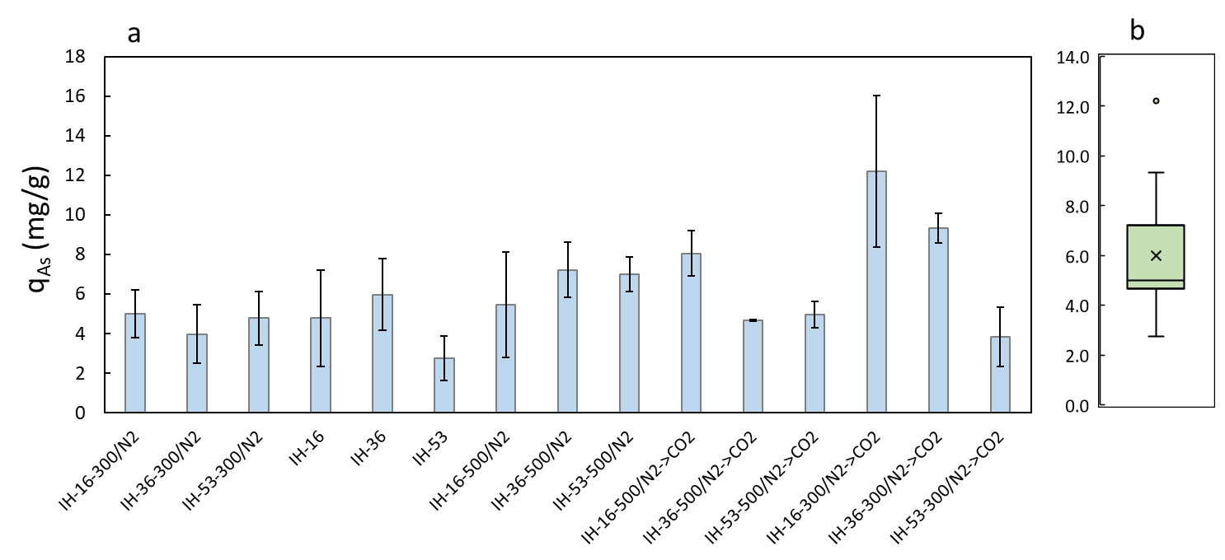
Figure 1. a) As adsorption capacity (q_{As}) measured for the different granulation-activation conditions. b) distribution of q_{As} for all analysed samples.
To assess the acid-base reactivity of the produced adsorbent, the HCl required to stabilize the pH at 5.0 ± 0.2 during the adsorption tests was measured and reported in Figure 2. In this case, analysis of variance indicated a significant positive effect (α = 0.01) for the factors Temperature and SS%. The amount of HCl required to neutralize the adsorbent increased (up to 9.6 mmol H⁺ g⁻¹) when the activation temperature was increased from 300 °C to 500 °C and when SS% was increased from 16 % to 53 %, indicating the formation of a more alkaline material.
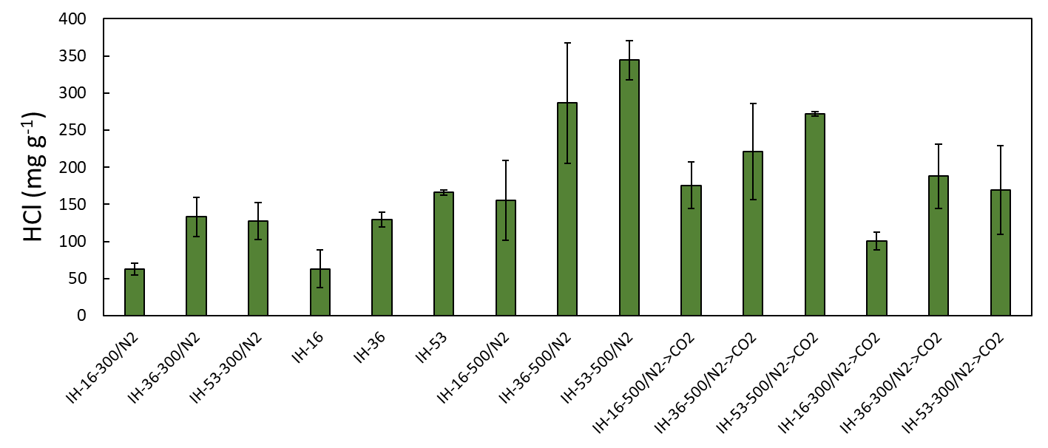
Figure 2. HCl consumed to stabilize the pH at 5.0 ± 0.2 during the As adsorption tests.
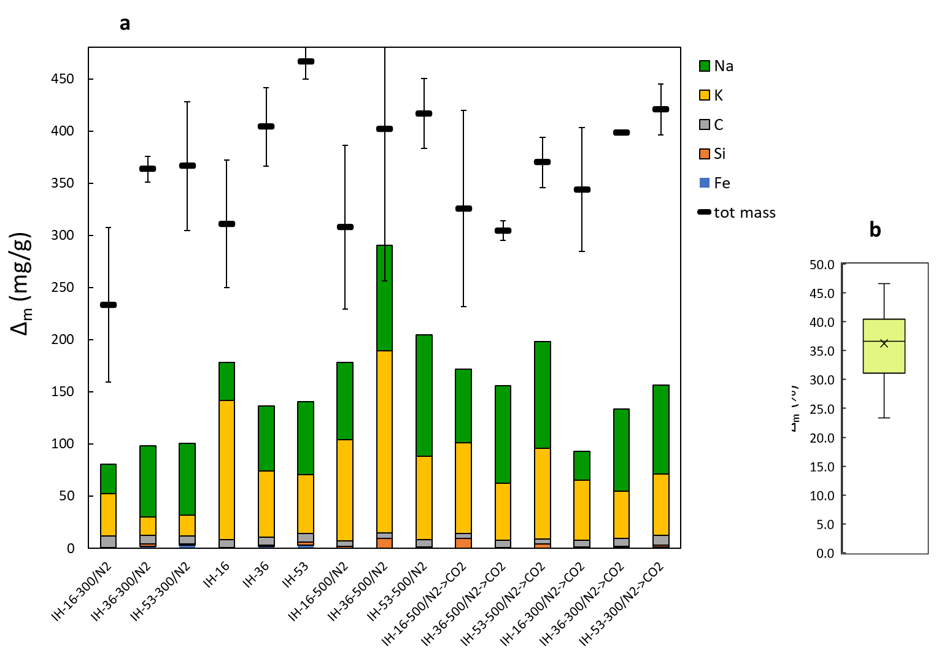
Figure 3. a) Mass of adsorbent lost (Δ_{m}) in water phase during the adsorption test in batch with the contribution of the elements Na, K, C, Si and Fe to the total mass lost. b) Distribution of Δ_{m} for all analysed samples.
All the adsorbents tested lost a fraction of their mass in the water phase (Figure 1a). There was no significant effect induced by the factors tested (α = 0.01), for an average value of 36 % loss and minimum and maximum of 23 and 46 %, respectively (Figure 1b). The analysis of the elements released in the water phase indicated that such a mass loss was mainly due to Na and K, which were respectively derived from the SS used in the granulation and KOH used for Fe precipitation. C, Si and Fe were not released at remarkable amounts, indicating no remarkable organic carbon loss occurred. The sum of the elements analyzed did not close the mass balance of the whole lost mass, suggesting that other elements gave a relevant contribution, likely mainly O as hydroxides and oxides related to K and Na. This mass loss is relatively high and should be reduced. The main reason for such mass loss was the utilization of magnetic stirring (with magnetic bars) that induced a mechanical beating of the particles, inducing their pulverization. The adoption of a packed column could reduce this side effect. A preliminary test conducted with a packed column operated for 18 h at controlled pH indicated no relevant change in the adsorbent morphology and a mass loss of 27 ± 2 %. Therefore, washing to stabilize the adsorbent seems mandatory before applying for water treatment.
Evaluation of the cost associated with the use of the binder
The variation in the SS% employed for the granulation gave a variable SS% in the final adsorbent obtained, resulting in a variable cost associated with SS purchasing. Considering the different yields obtained by the different activation conditions (Table 2), the SS% in the obtained final adsorbents was calculated by assuming that only organic species were lost during activation. A commercial SS solution (38 % w/w) was utilized, with a 0.38 € kg⁻¹ cost. For 16 % SS, the associated cost varied between 0.28 to 0.78 € kg⁻¹, for 36 % SS, the cost varied between 0.54 to 0.90 € kg⁻¹, while for 53 % SS, the cost varied between 0.65 to 1.01 € kg⁻¹. Considering the cost of conventional GFH adsorbents (5 - 10 € kg⁻¹), this preliminary assessment indicates that the amount of binder used can be compatible with the production of a cheaper adsorbent. A more comprehensive cost assessment will be required to consider the cost associated with the whole process.
  - Conclusions
This work showed how sodium silicate (16 - 53 %) could be employed as binder for granulating the Fe-doped hydrochar powder for producing 2 - 4 mm particles, effective on As removal from water (q_{As} up to 12.2 mg g⁻¹). Thermal activation increased the surface area up to 77 %; its yield decreased with temperature increase, while increased activation temperature and silicate % increased the alkaline property of the adsorbent, which required up to 9.6 mmol H⁺ g⁻¹ for neutralization. Residual K and Na, from hydrochar doping and granulation, were largely lost in the water phase during adsorption tests, indicating that a preliminary washing should be performed before its application for water treatment. The cost associated with the addition of silicate binder suggests that a production cost significantly lower than the conventional adsorbent could be attained; however a more comprehensive cost analysis on the whole process is still required.
Acknowledgments
Thanks are due to the LIFE Programme of the European Union for funding the LIFE BIOAs project (LIFE19 ENV/IT/000512). Isabel P.P. Cansado also thanks to LAQV-REQUIMTE, Instituto de Investigação e Formação Avançada, Departamento de Química, Escola de Ciências e Tecnologia, Universidade de Évora, Rua Romão Ramalho 59, 7000-671 Évora – Portugal.
References
Capobianco L., Di Caprio F., Altimari P., Astolfi M.L., Pagnanelli F., 2020, Production of an iron-coated adsorbent for arsenic removal by hydrothermal carbonization of olive pomace: Effect of the feedwater pH, Journal of Environmental Management, 273, 111164.
Di Caprio F., Pellini A., Zanoni R., Astolfi M.L., Altimari P., Pagnanelli F., 2022, Two-phase synthesis of Fe-loaded hydrochar for As removal: The distinct effects of initial pH, reaction time and Fe/hydrochar ratio, Journal of Environmental Management, 302A, 114058.
Gil A., 2021, Current insights into lignocellulose related waste valorization, Chemical Engineering Journal Advances, 8, 100186.
Miranda I., Simões R., Medeiros B., Nampoothiri M., Sukumaran R.K., Rajan D., Pereira H., Ferreira-Dias S., 2019, Valorization of lignocellulosic residues from the olive oil industry by production of lignin, glucose and functional sugars, Bioresource Technology, 292, 121936.
Nicomel N.R., Leus K., Folens K., Van Der Voort P., Du Laing G., 2015, Technologies for arsenic removal from water: current status and future perspectives, International Journal of Environmental Research and Public Health, 13, 62.
Podgorski J., & Berg M., 2020, Global threat of arsenic in groundwater, Science, 368, 845–850.
Rahaman M.S., Rahman M.M., Mise N., Sikder M.T., Ichihara G., Uddin M.K., Kurasaki M., Ichihara S., 2021, Environmental arsenic exposure and its contribution to human diseases, toxicity mechanism and management, Environmental Pollution, 289, 117940.

